Experiment 8

30th April 2019

Aim: To be able to write awk scripts.

---------------------------------------------------------------------------------------------
---------------------------------------------------------------------------------------------

1. Write a awk script that accepts date argument in the form of mm-dd-yy and displays it in the following format. The script should check the validity of the argument and in the case of error, display a suitable message.

Algorithm:
- Start
- Read argument
- If invalid or null argument , print error
- Store day, year, month separately
- Replace numeric month to alphabetical month
- Print “The date is “ day “Month is “ month “Year is “ year
- Stop

The code is as follows:

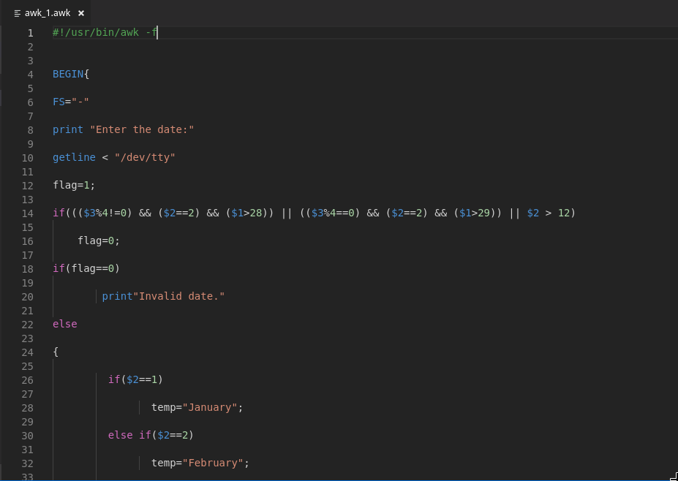

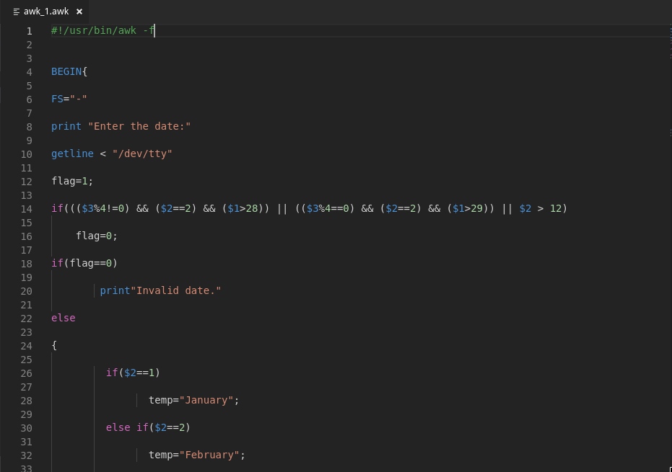
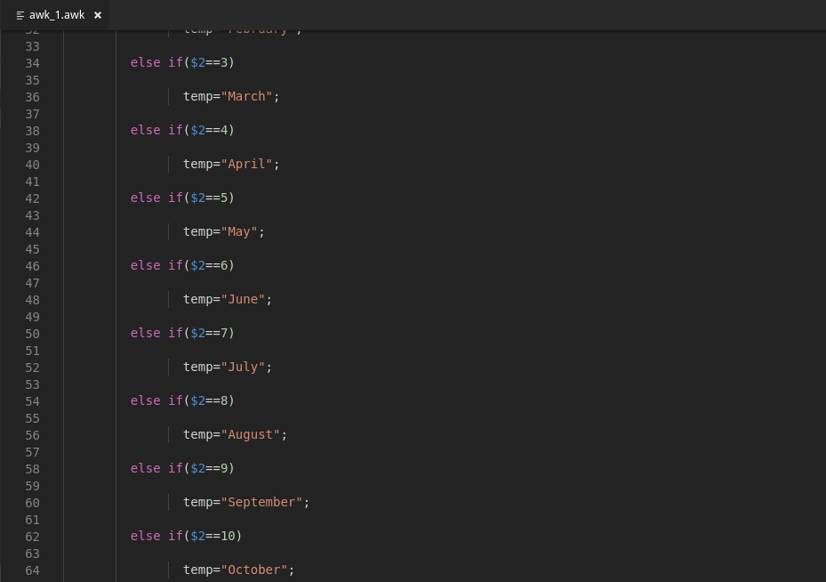
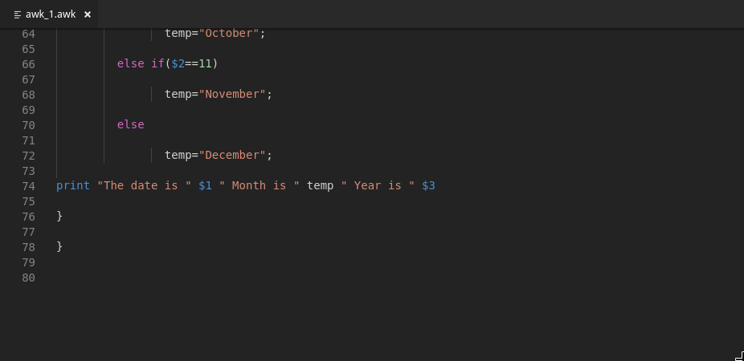

The output is as follows:

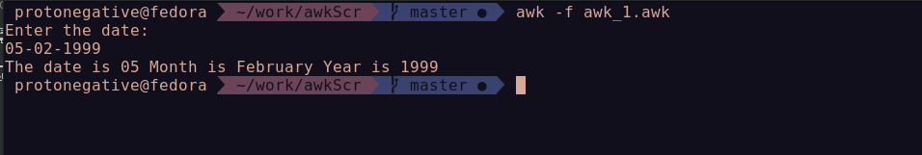

2. Write an awk script to delete duplicate line from a text file. The order of the original lines must remain unchanged

Algorithm:

- Start
- Read Argument
- If argument is invalid or null, print error
- Print file after deleting duplicate lines
- Stop

The code is as follows:

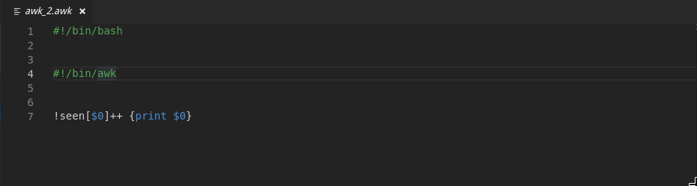
The file given as input is:

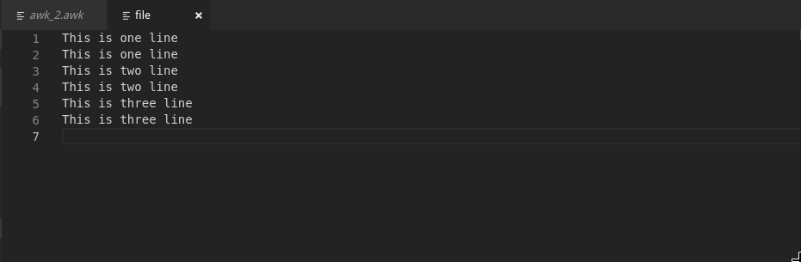
The output is as follows:


3. Write an awk script to find out total number of books sold in each discipline as well as total book sold based on the given table:

electrical 34
mechanical 67
electrical 80
computers 43
mechanical 65
civil 198
computers 64

Algorithm:
- Start
- Read argument
- If argument is invalid or null, print error
- Print total number of books sold in each discipline
- Print total number of books
- Stop
The code is as follows:

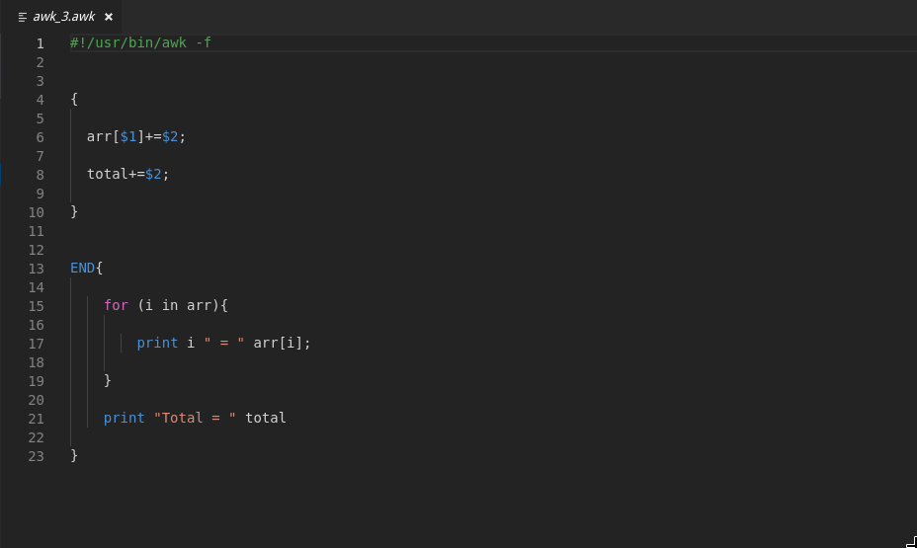

The file given as input is:

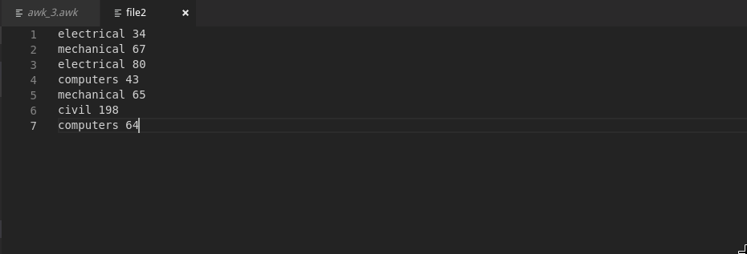
The output is as follows:

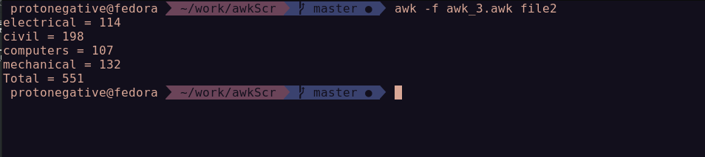

4. Write an awk script to compute gross salary of an employee accordingly to rule given below : If basic salary < 10000 then DA = 45% of the basic and HRA =15% of basic If basic salary >= 10000 then DA =50% of the basic and HRA =20% of basic.

Algorithm:
- Start
- Read Salary
- If ( salary < 10000 ) then
- DA = 45% of salary
- HRA = 15% of salary
- Else
- DA = 45% of salary
- HRA = 50% of salary
- End if
- Gross salary = DA+HRA+salary
- Print gross salary
- Stop

The code is as follows:
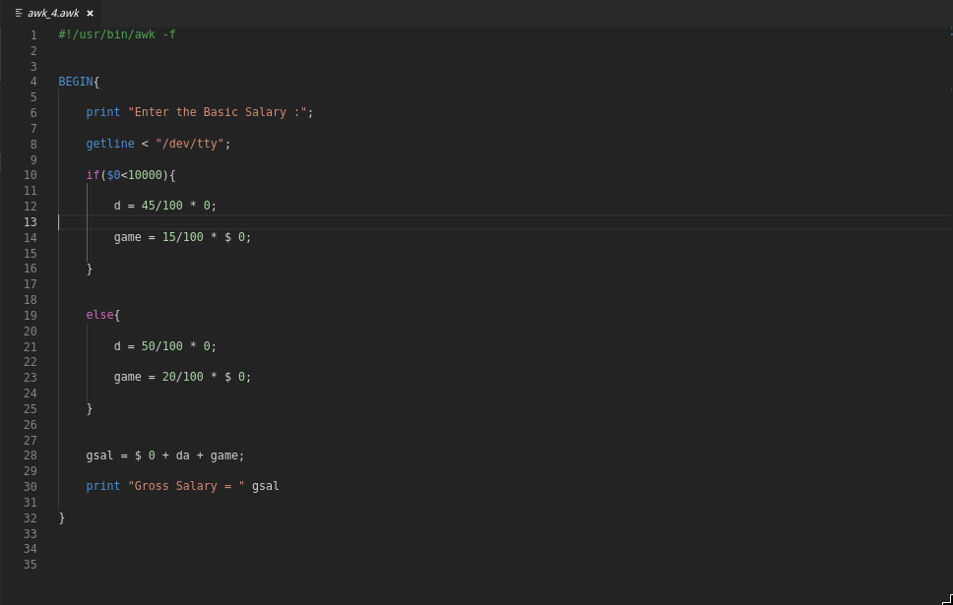

The output is as follows:
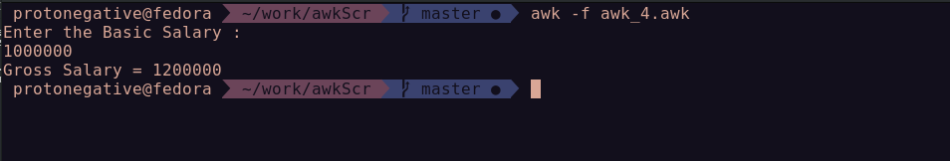

Result: Learned to write awk scripts.

---------------------------------------------------------------------------------------------
eof
---------------------------------------------------------------------------------------------

